CS4640 A<2>

<Yingjie Lian>

September 5, 2019

**Question 1 Answer:**

Here are the codes that I have used: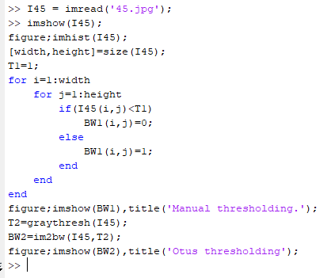

I first looked at the original image and its histogram of thresholding.

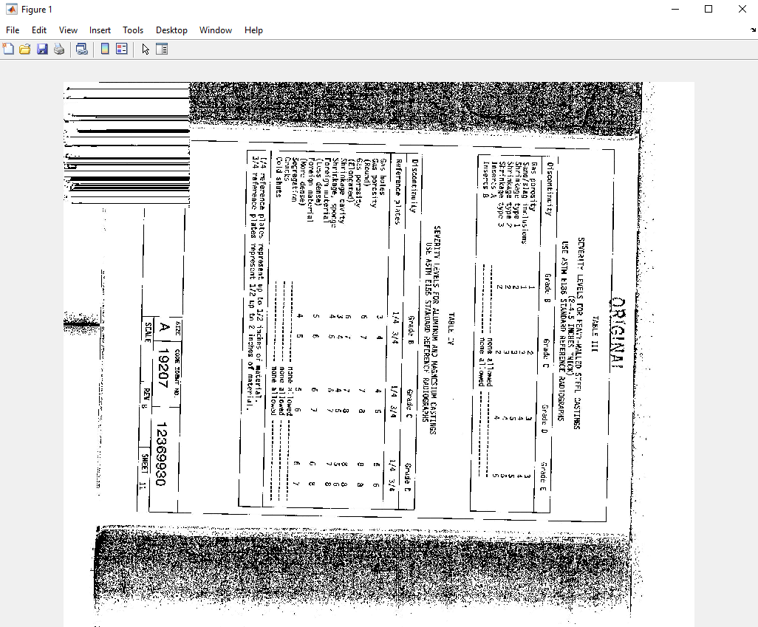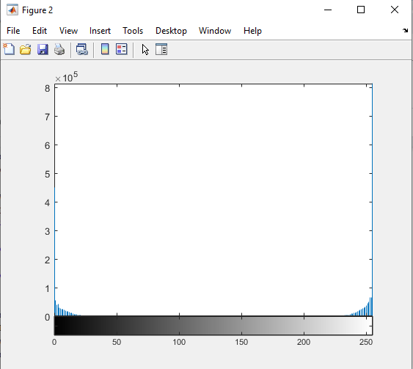

(original image) (histogram of thresholding)

Looks like the thresholding values are around 1 and 255. So I have choose 1 as my thresholding value for Manual thresholding testing and use im2bw() and graythresh() function for Otus thresholding value testing. Here is what I got:

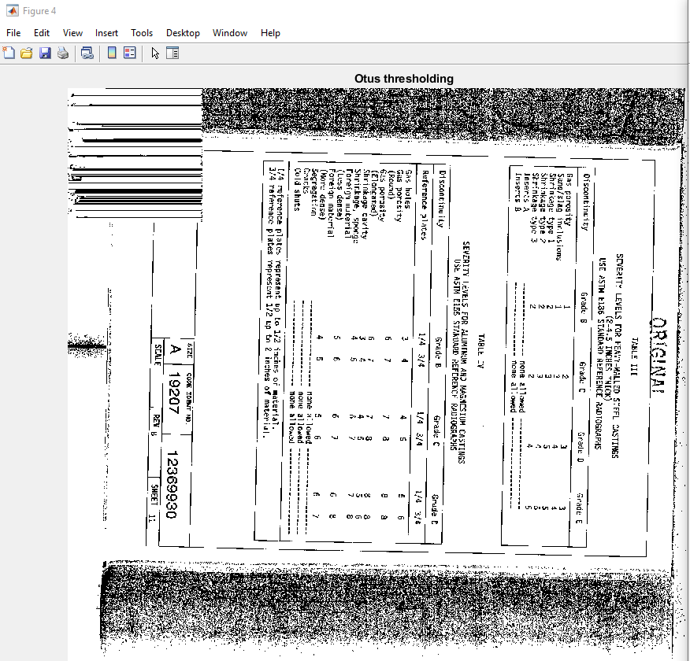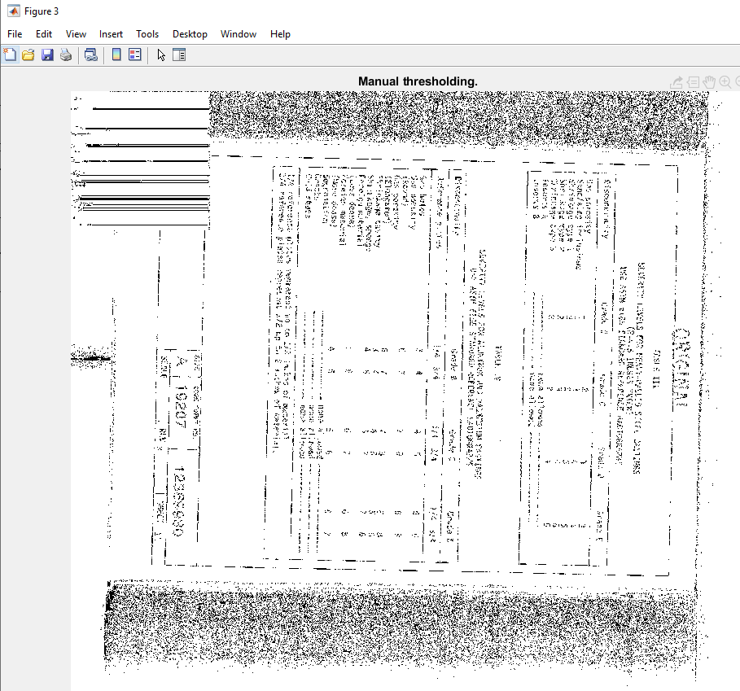

(im2bw) (Manual thresholding)

As we can see, but using 1 as my thresholding value, the image became distortion.

But if I use, the image will also become distortion

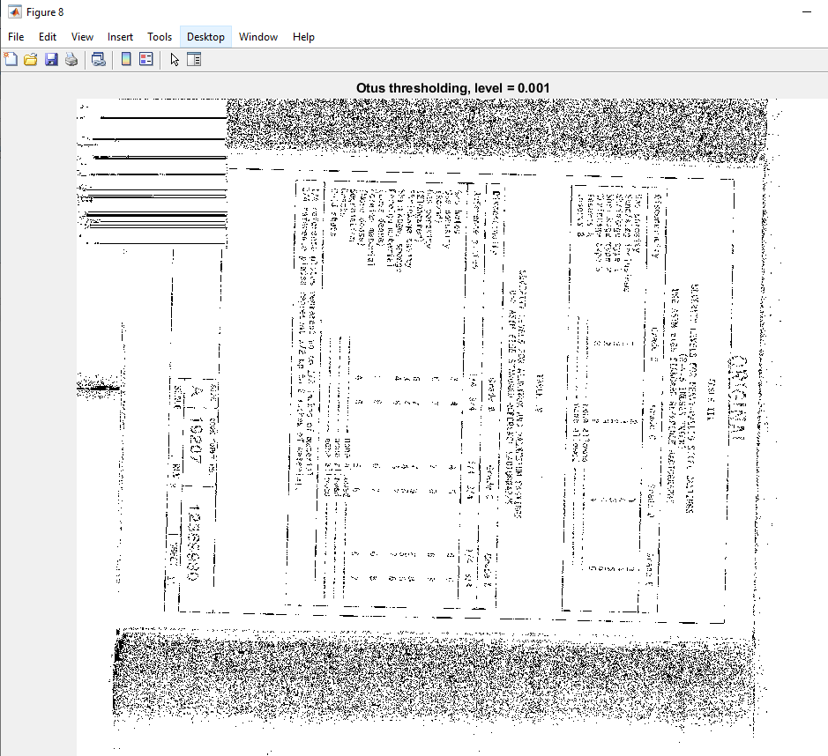Since I have changed its second parameter to 0.001.

But I think the best method is still do the Manual thresholding for the image because it can be more accurate by selecting the thresholding value rather than using im2bw() function. Since the second parameter of im2bw() only corresponds to an intensity value of percentage between the minimum and maximum value of the class.

However, after I have done my for loop manual thresholding function to **56.jpg** I changed my mind. The reason was that it took so long to threshold that image while using the two for loops.

**Question 2 Answer:**

Here is the histogram of thresholding of **45.jpg**.



Looks like the thresholding values are around 1 and 255. There are no more values are bigger than 50 and smaller than 200.

Based on the histogram I got, I have changed my thresholding value to be less than 50. Then I got my text and markings: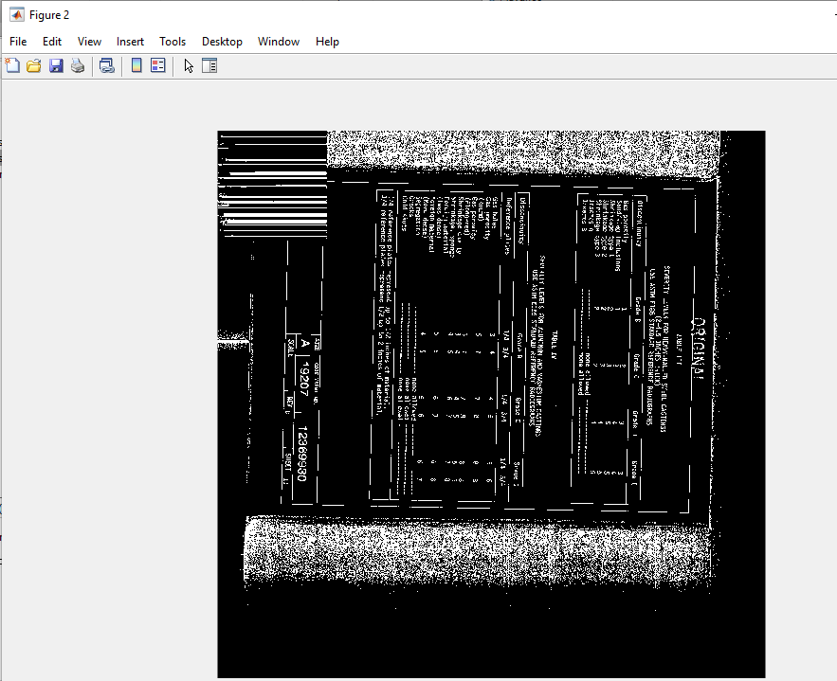

**Question 3 Answer:**

First I got the histogram from **map1.jpg**

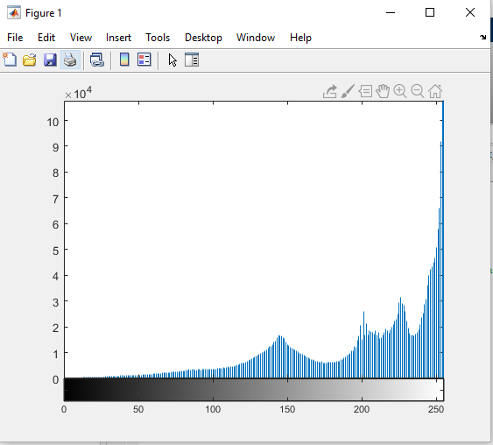

As we can see, there are 4 peaks around the x-values of 150, 200, 230, 255.

Then I have generated 4 binary images based on that:

Threshold between 140-160:

The white area are the text, roads, railways and border lines.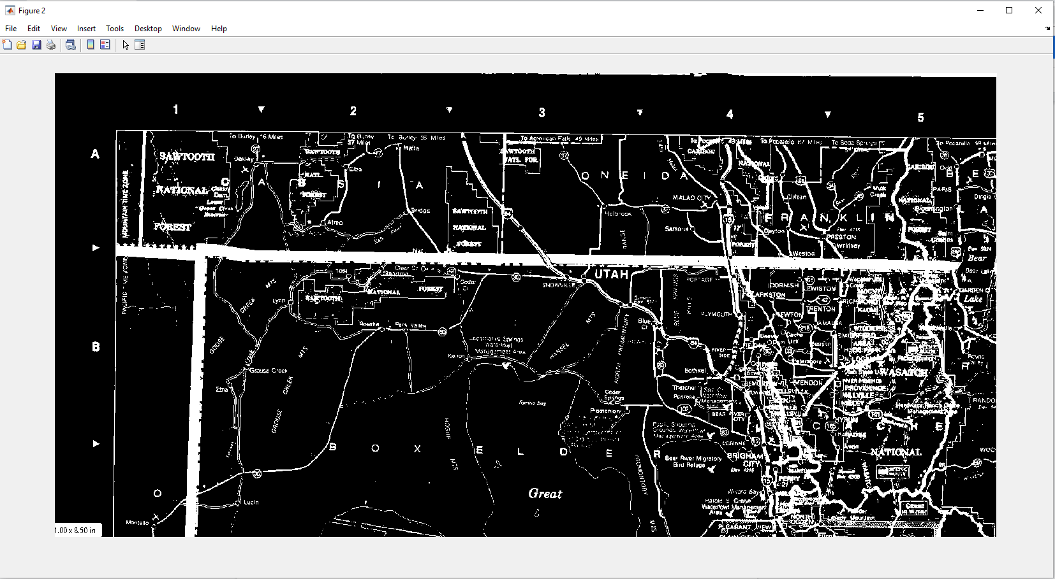

Threshold between 190-210:

The white areas are the water area and forests.

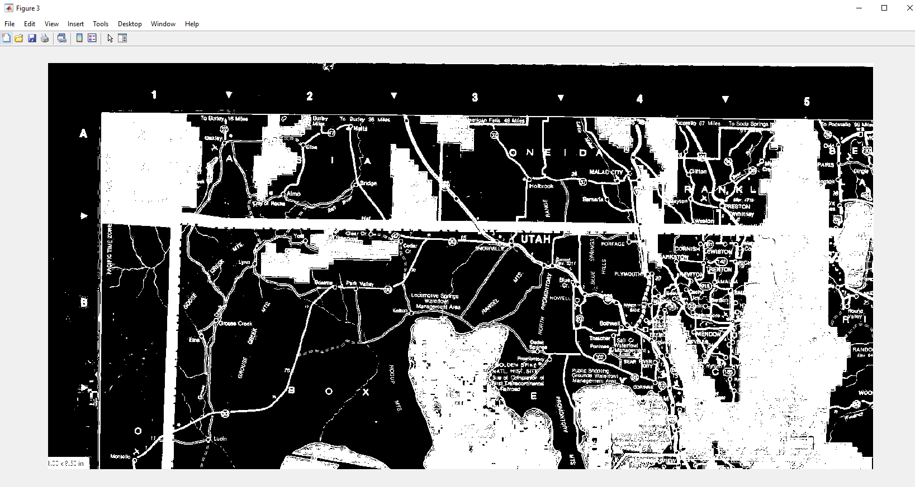

Threshold between 220-240:

The differences between this one and the last one is that the border of the map became white from black.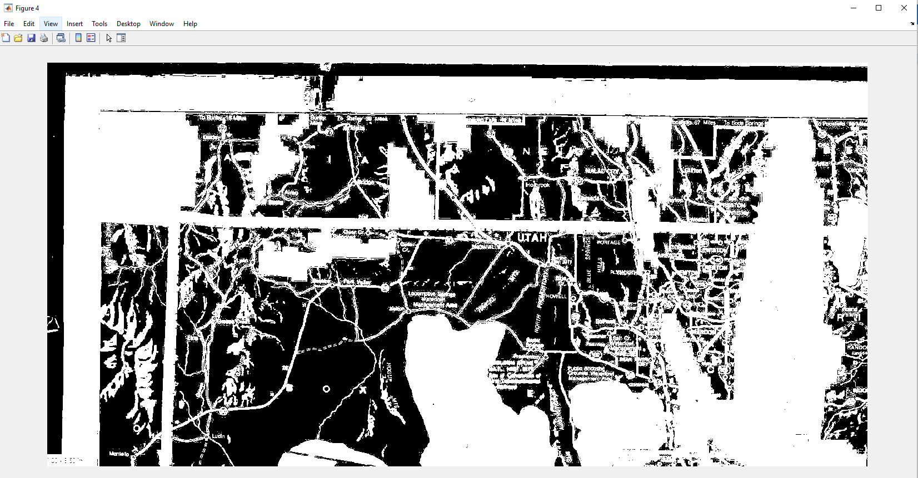

Threshold between 245-255:

The black areas are only lands.

